First Project

Getting Started the IDE
During this Visual Basic course, you will learn about the design of Visual display of programs and how to instruct the computer to change things when events happen.
Start Windows on the computer, one of the Start menu Items should be Visual Basic. From the Start Menu Program List start Visual Basic, once it has started a New Project Dialog Box will be shown (see below). This Dialog gives many possible choices; for the most of the course, you only need to learn about three choices. The first and most used option will be the ‘Standard EXE’ option on the ‘New’ tab. The other options are to load an existing or recent project from the Existing or Recent tab. For a new standard project, select Standard EXE by clicking and then Click Open (or Double Click Standard Exe).
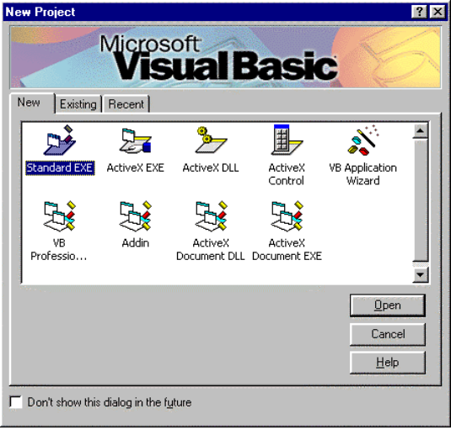
When the new project is started, Visual Basic may be arranged as the screen shot on the next page. The exact layout may vary from computer to computer. There are principally nine areas within the Visual Basic IDE (Integrated Development Environment). These part windows are as shown in the screen shot on the following page follows from top left to bottom right.
- Program Title Bar usual to have project name in the title.
- Menu bar used in the same as any menu system of windows' program.
- Tool bar icon used for Save, Open, Start and Stop.
- Toolbox icons used for selecting items for Design.
- Code window.
- Project window information on files used by the program.
- Properties' window information used to show the setting of the selected object.
- Object window with the layout of form shown while designing the program.
- Form Layout window which shows where the forms will appear when the program runs.
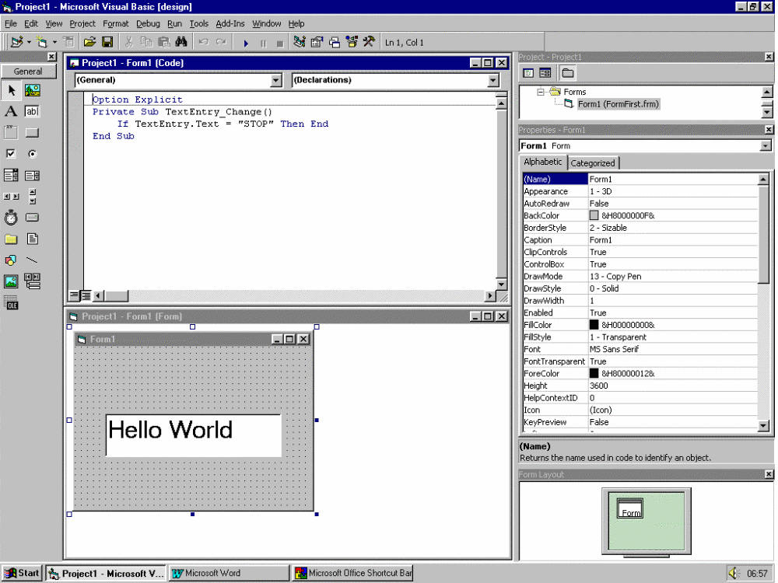

Your First Project
The first action that is advisable before starting to write your first program is to create a new directory/folder in to which the files required to contain the instructions of your program. A suggestion for the first project folder is “FIRST”.
The Objective of the first application is to display a form with two text boxes. The first box will allow the user to enter some text into the program. The second text box will not be editable but will show the same as the first box on pressing the copy button.
The application will consist of the following items (objects)
- One form: This is the screen of the window program.
- Two text labels: These are used to display prompt information.
- Two text boxes: One box for input and one box for Output.
- One command button: To create an event on which actions will take place.

Creating the new project
Start Visual Basic and then select the following items.
- Standard EXE and Open
- From the menu bar File menu, select Save Project in order to save the project and the form into your new directory.
- The First File to save is usually the form file. This file will have an extension of frm added to the end of the name. The Suggested file name will be Form1.frm, but use your own name for the file name. (For example Graham.frm)
- The second file to save is then usually the project file. This file will have a file extension of vbp (visual basic project). Again there will be a suggested file name of Project1.vbp, but again use your own name for the file name.
When Visual Basic started, it will have created a blank form automatically. The other objects needed for the program can be selected from the Tool Box by either of the follow methods.
- Left clicking on the item required and then point to the place on the form where the object is required on the form. Then click and drag the mouse with the left mouse button down on the form.
- Double click the object required and it will appear a fixed size somewhere on the form. (Usually in the middle)
When an object has been placed, on the form it may be resized or repositioned by pointing at the object, then with the left mouse button held down drag before letting go of the button. (This process is very similar to other windows programs.)
- Place all five objects on the form and position then to give a reasonable layout.
- Point at and then click the mouse on the first label. When an object is active, you should see eight squares around the edge of the object. Also the properties’ window will have the selected objects properties listed.
- Now click on the properties window in which the properties for label1 should be visible. In this window, we can change the values by clicking the property item in the list and then select from either a pre-set list or keying in a value depending on the type of item.

For Label1
Select the Caption and edit it to read Enter Text.
Select the font by clicking the button, which appears on the right of the font property - select a larger size of 14.

For Label2
Select the Caption and edit it to read Copied Value.
Select the font by clicking the button, which appears on the right of the font property - select a larger size of 14.

For text2
Select the Locked item and set it to True.

For Command1
Select the Caption and edit it to read Copy.

For the Form
Select the Caption and edit it read First Project by and your name.
The Program should look something like this.
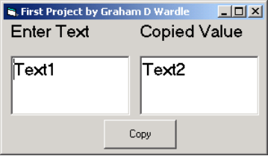

Adding Code
The Visual part of the application is now ready but we still do not have any thing that drives the empty shell. We now need to add the engine to drive the program. In order to add code select the command button and then select the code window. This can be done in any one of the following ways.
- Double Click the Command Button.
- Select the Code Icon in the Project Window.
- Select code window
- Select the menu View and Code
- Select the menu Window and Project1 -Form1 (code)
When the program code is selected, it should look something like this.
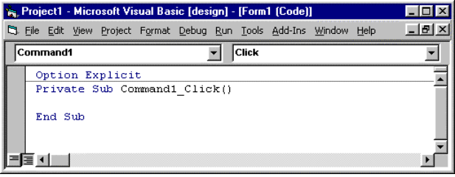
This is the part where you add the BASIC language code, which will provide the specific actions in your program. This window is part of the text that will be stored in the form file when it is stored on the disk.
On the top of the window, you can select the object and event for which the code is to act. The object determines which object within the form this code relates. The event determines under what circumstance this code will be called. In this case, we are looking at the click event of the command1 button. That is when the Command is clicked (that is pushed).
Enter the code between the Sub and the End Sub as follows.
Private Sub Command1_Click()
Text2.Text = Text1.Text
End Sub
The basic code will make the text of the text2 object equal to the text of the text1 object when the command button is pressed.
The name of Text2 followed by the ‘.’ indicates that BASIC is to take a property that object. The text property of the object is the property being changed in this case. There are many more, some of them you will use as part of this course and some you will not. When writing any Visual Basic Program you will tend to use only about 10% of the possible properties for 90% of the time. Only on very rare occasions will some of the more specialised properties get used.

Running the program
Your application is ready to run.
- To start the program use the Run Icon in the toolbar, the Run Start of the menu bar or Press F5.
- Enter some text into the first text box (“Hello World” to maintain a tradition) Notice you cannot enter anything into the second text box since it has been locked.
- Now press Copy button
- In order to stop the program you can use the close option on the program title bar or press the Tool bar Stop Icon.

Developing the program
Now that you have tried your first program, you can look at ways to develop the program further. One suggestion would be to test the text of text box 2 when the value is copied. If the text is, “End” when copied then the program closes. Add the following code after the copy code.
if Text2.Text = “End” Then End
Try the program by typing END or by typing end in the text box. Neither of these should end the program. The reason is that “END” is not the same as “End”.

Note on Visual Basic and case sensitivity
Visual Basic programs can distinguish the difference between lower and upper case text stored in properties such as text. The text used for code is not case sensitive and in fact, any words typed will try to match existing names. If a match is found for a name, then the text in the new line will morph to match every other occurrence of the name. As an illustration of this, the line over if typed as below would change back to the same as above.
IF tEXT2.text=”End” THEN end
The precise rules for the letter morphing are not needed for this course.

Adding comments to programs
When developing programs it is sometimes useful to write notes to yourself or other members of the development team. Visual Basic mechanism for doing this is a single quote mark at the start of the line. For this first project add comments at the top of the code page
' First Project for Visual Basic 7262 204
' Developed 1 February 2002
' Author Graham D Wardle
' West Cheshire College
' Modified for City and Guild eQuals
Option Explicit
Private Sub Command1_Click()
'copies text from first text box to second
Text2.Text = Text1.Text
'test for text of End
If Text2.Text = "End" Then End
End Sub

Using Find and Replace tools of the IDE
Sometimes when changing a programme it is useful to be able to find some text or find and replace text.
To try out the Find tool look for word text in the code. To activate the Find tool use either Alt E and F (Edit Find) or Ctrl F. There are various options such as find in the current module or current project. Enter the text you wish to look for in the Find What combo text. If you wish to look for something that was searched for previous use the combo list to select that from the list.
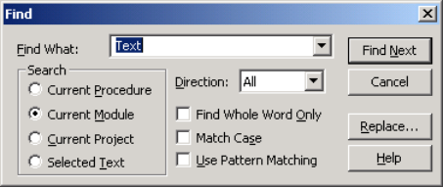
This will then find all places in the code where the text of “Text” is found.
Next press the replace option and enter the text of “End” in the find what combo and “Goodbye” in the Replace with combo. Then use “Find Next” to find and the “Replace” to replace End with Goodbye. Note the text is in quote mark so only the tested text is replaced.
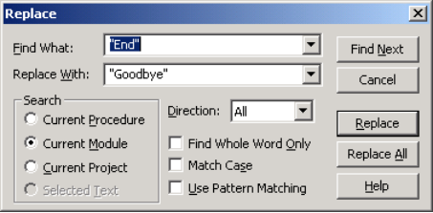
The result of these changes the program code should look something like that below. Note that some of the child windows of Visual Basic have been closed to reduce the size of the screen shot.
